Relaxation Exercises:

Calm Body Strategy

Wall Push-ups

Stand up near a wall.

Put your hands to the wall and then do a push up – bringing your body close to the wall and pushing away. Breath in as your body is getting close to the wall, breath out as you push away from the wall.

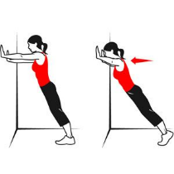

Calm Mind Strategy

Visualization Destination

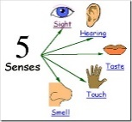

Imagine yourself in your favorite place – where you feel safe and happy. Use all your senses to

What do you:

See?

Hear?

Feel?

Taste?

Smell?